Nursery Extension
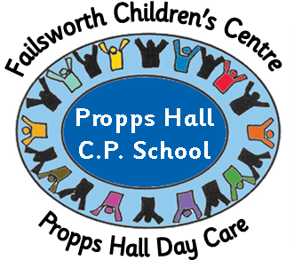
It is with great pleasure that we are pleased to announce that our extension work will be completed for the beginning of April.
Propps Hall Day Care will, therefore, be shut for one week in order for removal of furniture and resources and the setting up of the new building.
Propps Hall Day Care will close at 5:45pm Friday April 15th and reopen at 7:45am Tuesday April 26th (please note this also includes the Foundation Unit at Propps Hall CP School).
I’m sure you’re all as eager as we are to see the finished article!!
Red Nose Day 2011
Staff did something funny for money for Red Nose Day this year…. By dressing up as members of the opposite sex!
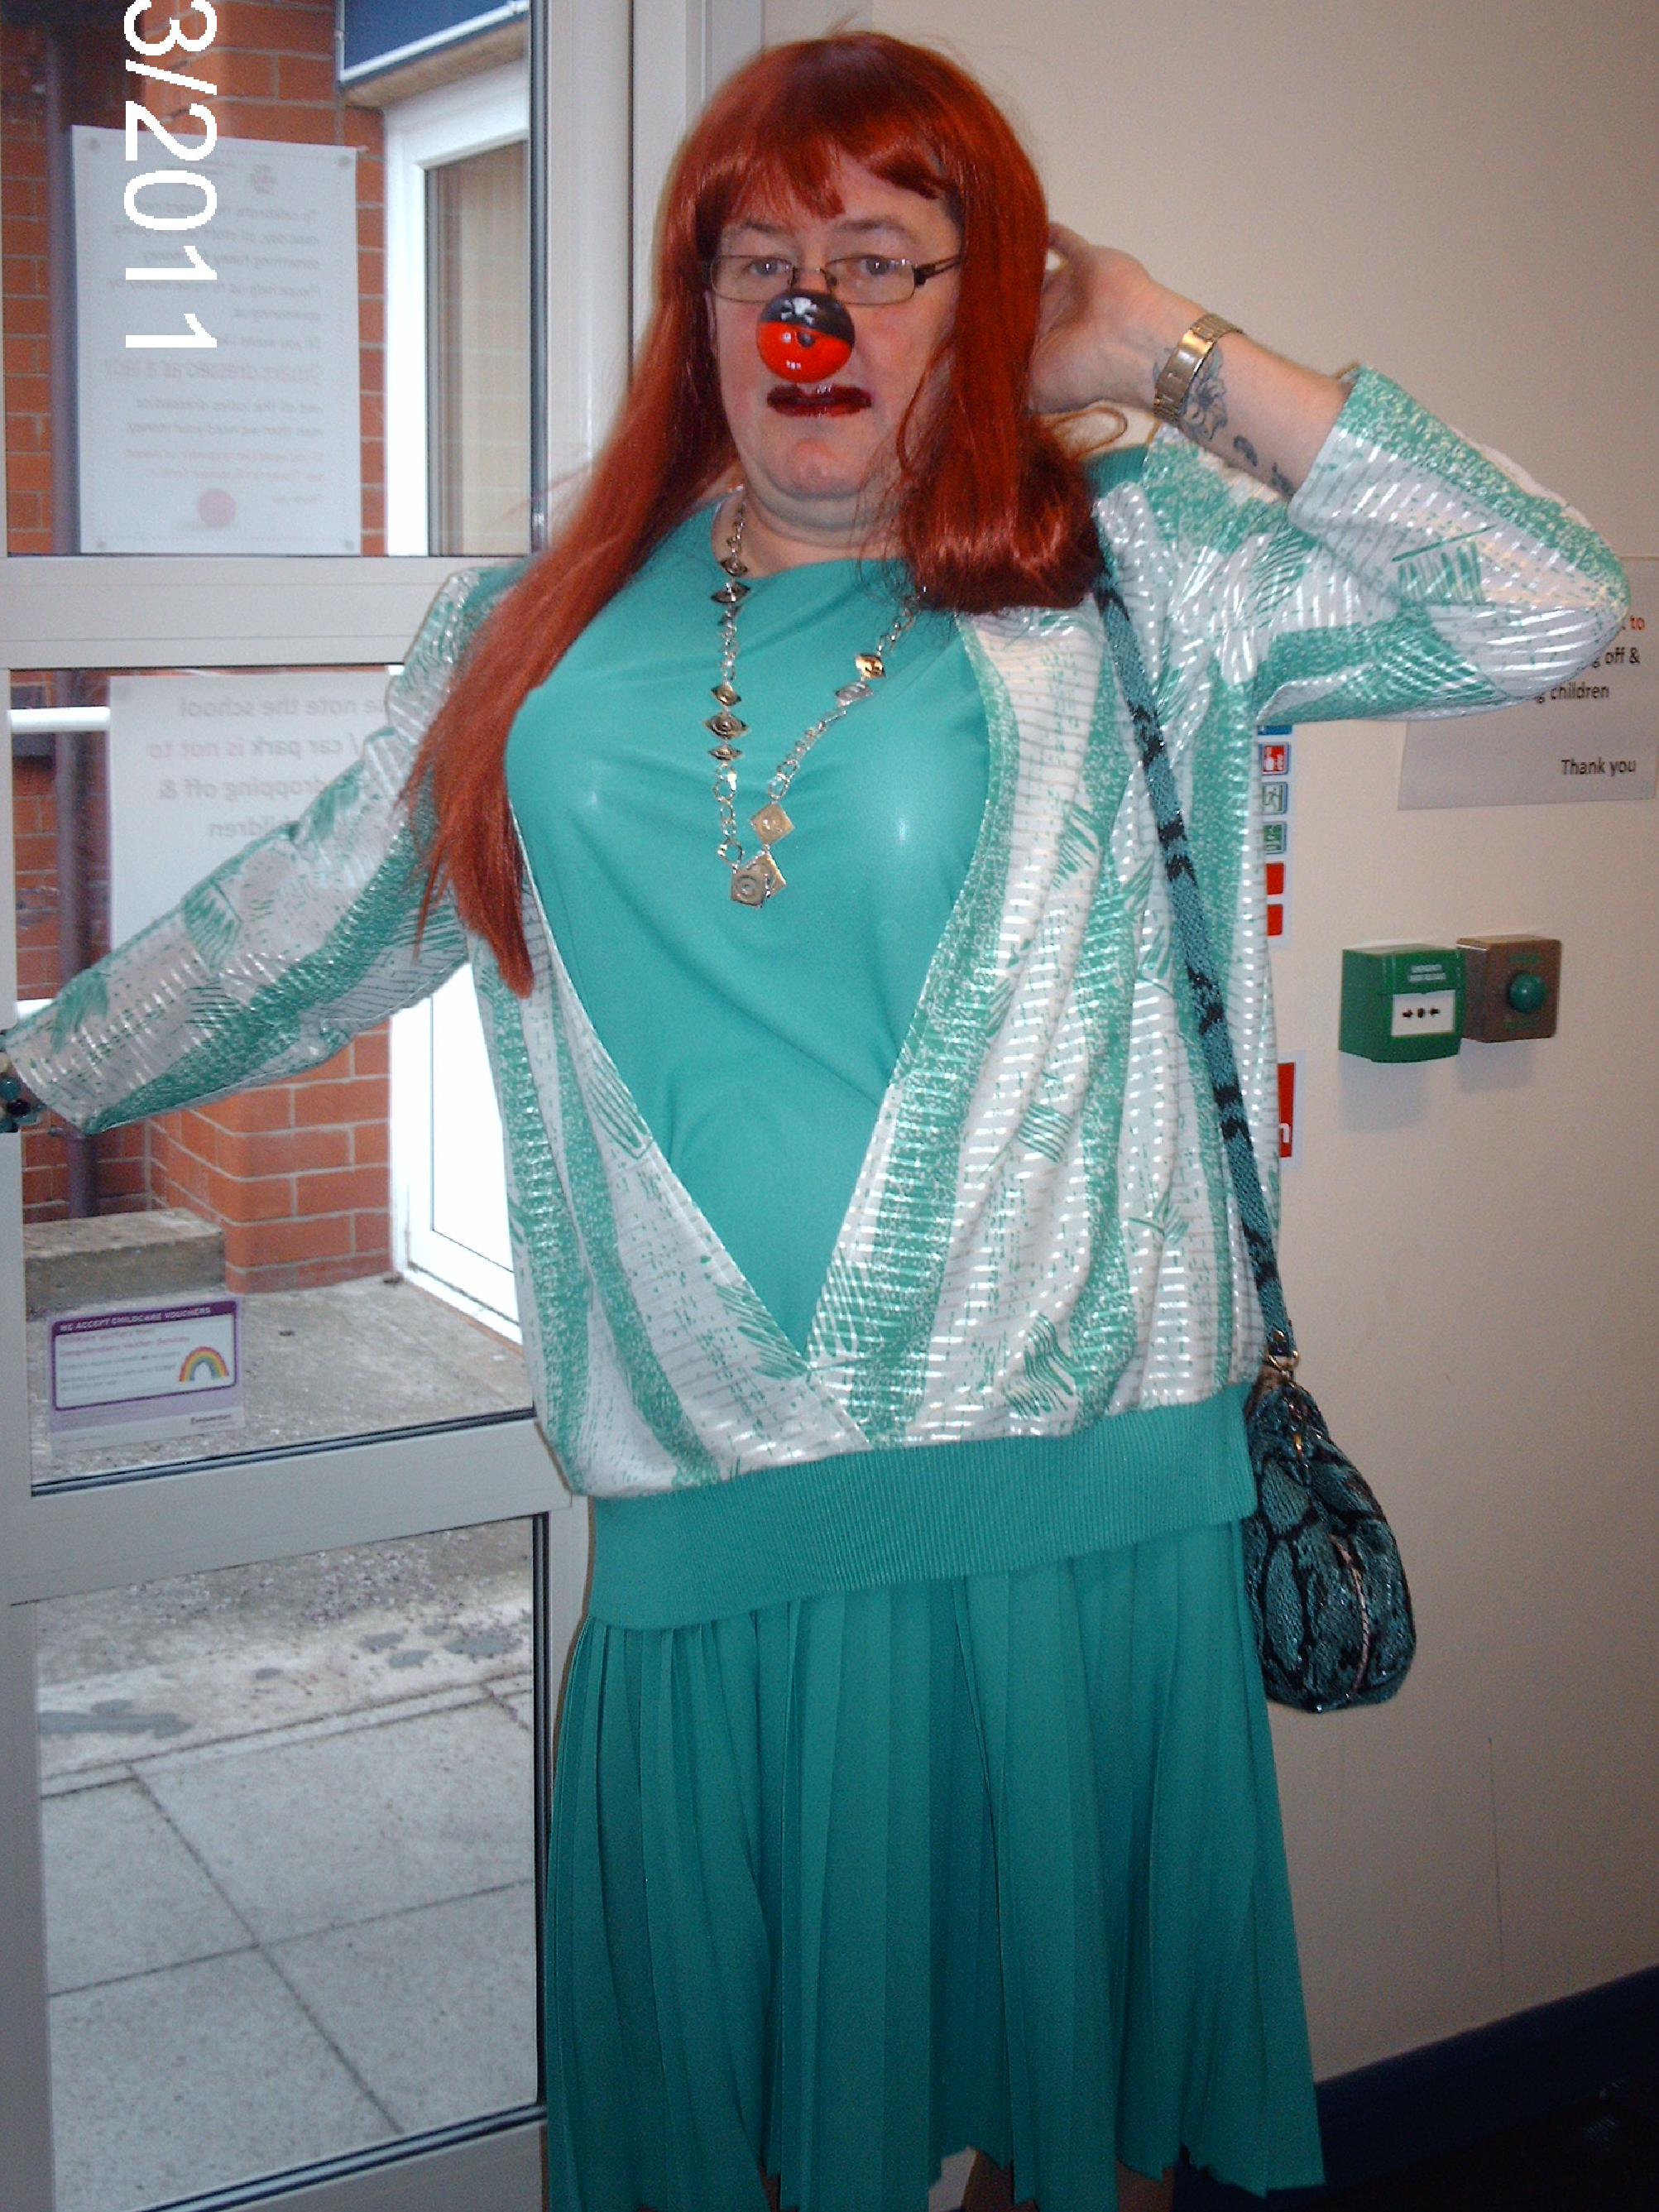


So far we have raised £63.50, if you are still to pay your sponsorship money please pass it to Tracey.
Best regards
Rachel and the Day Care Team

